### Part 2: Days of the Week

1. 5’: display initial current time before setting (call display_tb before setting current time Timeset=1 for the first time): '00000', only 1 digit for day, all initial values are 0.

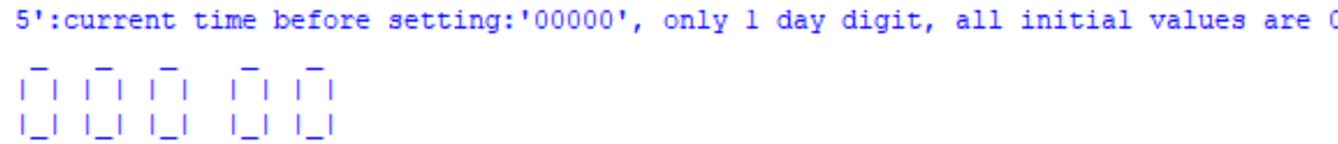

1. Then set almart to be 08:01.



1. Set current time to be ‘40730’ using Timeset=1

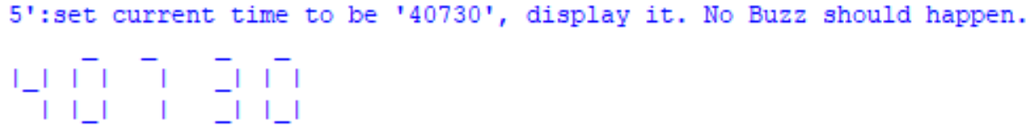

4.

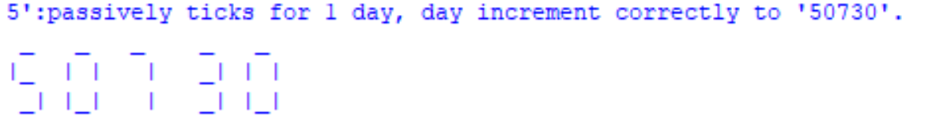

5.

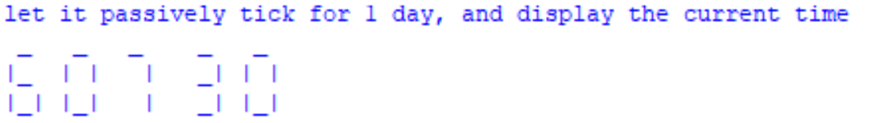

6.

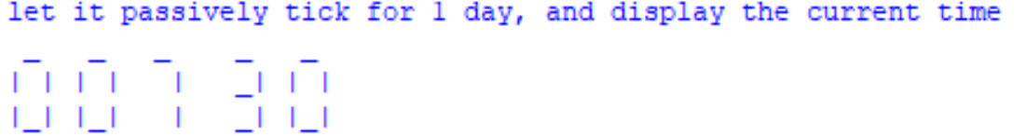

7.

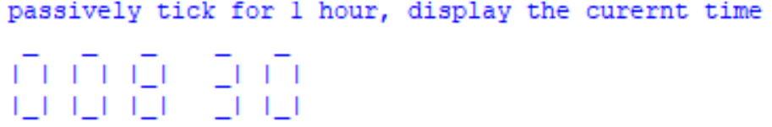



### Part 3: Date and Month

1. 5’: Displaying “010100000” as Jan 1 in the beginning (call display_tb before setting current time Timeset=1 for the first time). The last 4 digits are not considered in grading this part.

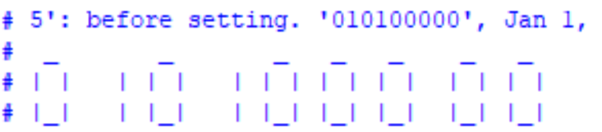

1. 5’: set the month/date/time to be “12310” by using Timeset=1.

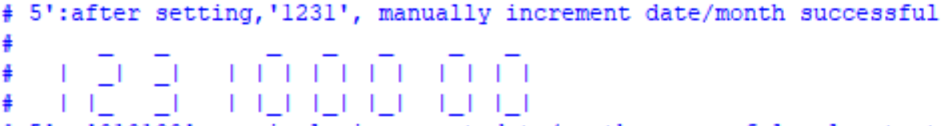

1. 5’: Let current time passively ticks for 1 day (when Timeset = 0), then it should become ‘01011). The 5th digit becomes 1 because the “day of week” also increments.

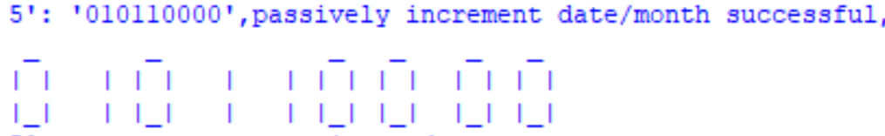

1. 5’: mod for different months.

Manually change the date to Feb 28 (by Timeset = 1), display it; then let it passively ticks(Timeset=0) for 1 day, display it. It should display March 1(0301).

Then manually change the date to April 30 (by Timeset=1), and let it passively ticks(Timese=0) for 1 day, then it should display May 1(0501).

